
National University of Technology

Machine Learning - CS3503

LAB Submitted to:

Lec.Hajra Ahmad

Submitted By:
Muhammad Abdullah

Reg. No: F22607010
Batch: Fall AI 2022
Assignment : 03
Q.NO.1:
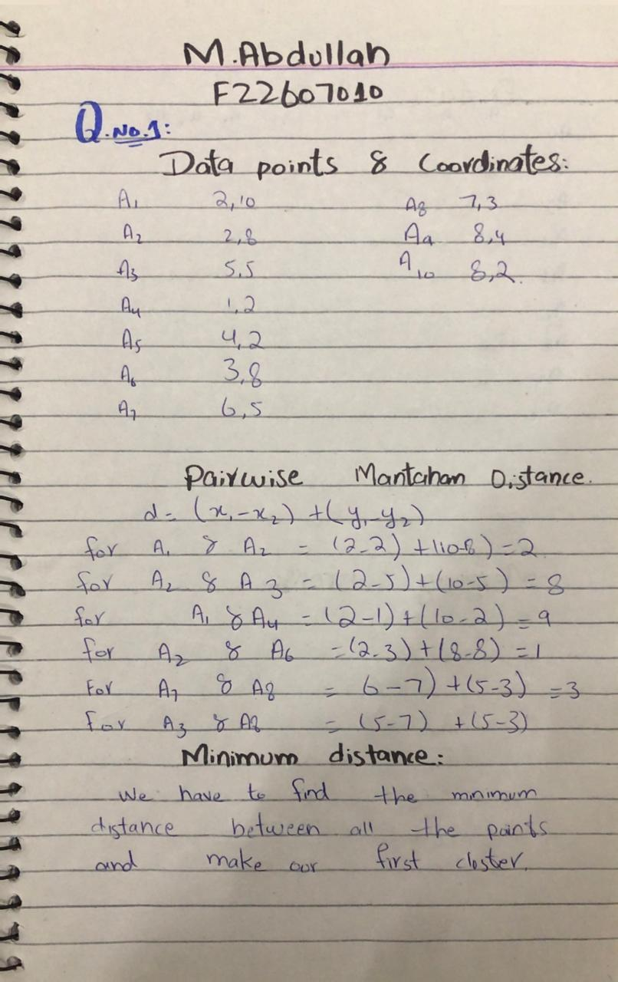
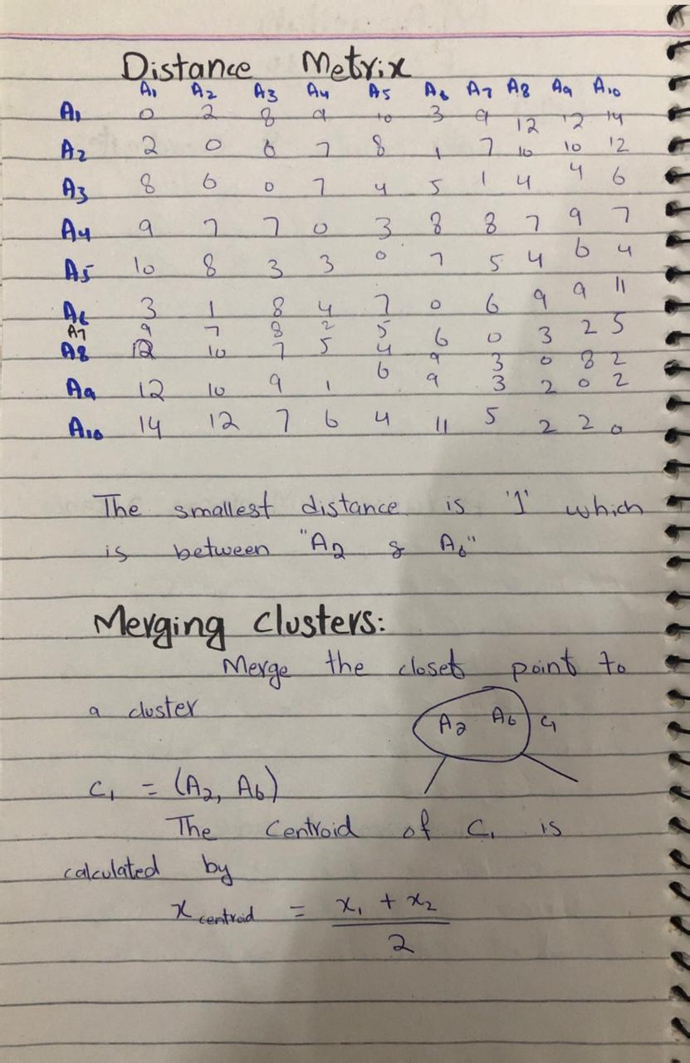
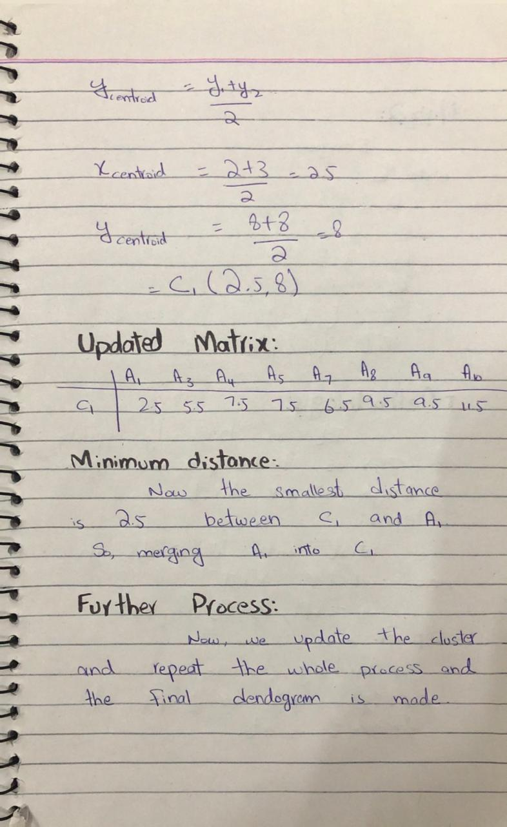
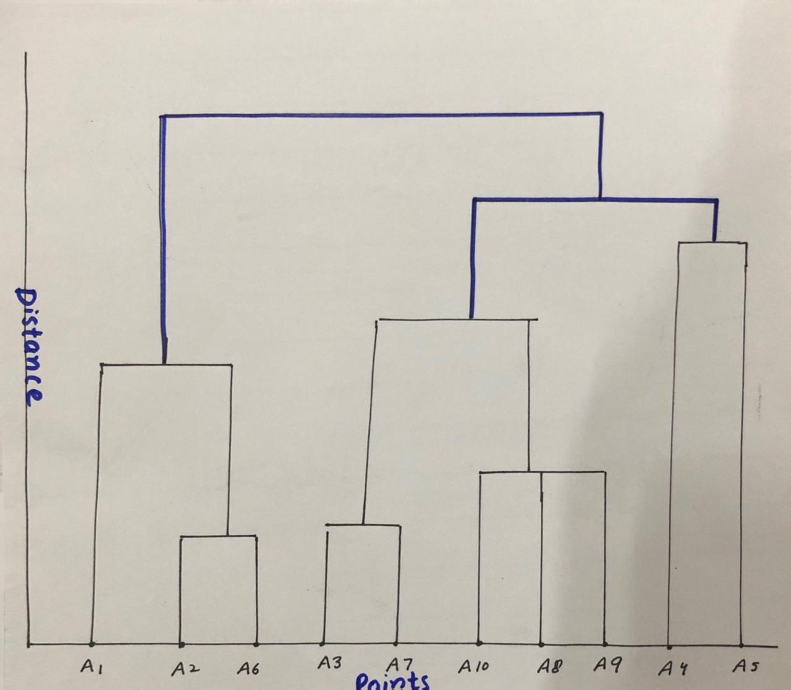

Q.No.2:


